Data Analysis and Design

Assignment 2

**Submitted To: Sir Zammad Farooq**

**Submitted By: Eman Amer Dar | 28692**

Table of Contents

[2.1 1](#_Toc477624025)

[Introduction 1](#_Toc477624026)

[Purpose 1](#_Toc477624027)

[Intended Audience and Reading Suggestions 1](#_Toc477624028)

[Product Scope 1](#_Toc477624029)

[Overall Description 1](#_Toc477624030)

[Product Perspective 1](#_Toc477624031)

[Product Functions 2](#_Toc477624032)

[User Characteristics 2](#_Toc477624033)

[Use Case Table 3](#_Toc477624034)

[ERD (Entity Relationship Diagram) 6](#_Toc477624035)

[Operating Environment 6](#_Toc477624036)

[External Interface Requirements 7](#_Toc477624037)

[Hardware Interfaces 7](#_Toc477624038)

[Software Interfaces 7](#_Toc477624039)

[Other Non-functional Requirements 7](#_Toc477624040)

[Performance Requirements 7](#_Toc477624041)

[Security Requirements 7](#_Toc477624042)

[2.2 8](#_Toc477624043)

[Designed Database 8](#_Toc477624044)

[Relationships 8](#_Toc477624045)

[Tables 8](#_Toc477624046)

[Building Table 8](#_Toc477624047)

[Employee Table 9](#_Toc477624048)

[Tenant Table 9](#_Toc477624049)

[Type Table 9](#_Toc477624050)

[Lease Agreement 10](#_Toc477624051)

[Manager Office 10](#_Toc477624052)

[Kins Table 10](#_Toc477624053)

[2.3 11](#_Toc477624054)

[Types of Forms 11](#_Toc477624055)

[3.1 17](#_Toc477624056)

[Query Tool 17](#_Toc477624057)

[Benefits 17](#_Toc477624058)

[3.2 18](#_Toc477624059)

[Query Implementation 18](#_Toc477624060)

[3.3 19](#_Toc477624061)

[Critical Evaluation 19](#_Toc477624062)

[Retrieving Meaningful Data 19](#_Toc477624063)

[SELECT Query 20](#_Toc477624064)

[4.1 21](#_Toc477624065)

[Critical Review 21](#_Toc477624066)

[Testing 21](#_Toc477624067)

[Input Testing 21](#_Toc477624068)

[4.2 23](#_Toc477624069)

[Support 23](#_Toc477624070)

[For Implementation 23](#_Toc477624071)

[For Testing 25](#_Toc477624072)

[4.3 26](#_Toc477624073)

[User Documentation 26](#_Toc477624074)

[4.4 27](#_Toc477624075)

[Validation and Verification 27](#_Toc477624076)

[Verification 27](#_Toc477624077)

[Validation 27](#_Toc477624078)

[Validation and Verification of System 27](#_Toc477624079)

[4.5 28](#_Toc477624080)

[Control Mechanism 28](#_Toc477624081)

[Bibliography 29](#_Toc477624082)

# 2.1

## Introduction

The property management system for Darsons’ Property Management Company is designed so that the records of the company can be stored online in the database that can be accessed online and data being stored on the registers and files can be wave off.

## Purpose

The Darsons’ Property Management Company needs to computerise the records that are stored by writing on registers. By computerising the system the data stored will be done more efficiently with the help of database in which the records of the people are stored online and instead of writing it on registers and storing a bunch of files and registers store it on a database online.

## Intended Audience and Reading Suggestions

This documentation is done for the Property Management Company. By reading this the company will understand that how to use the management system designed for the company. If any trouble occurs then by reading all the documentation the user will understand that how it can be processed and how to deal with the problem.

## Product Scope

The scope of this management system is that it could be very essential for the future use. The data of the people that are signing the agreement to live in the apartments and the employees and many other records of the Darsons’ Property Management Company can be stored in the database and the backup is provided so that in the case if the data is loss it can be restored. The storing of data in the database is more essential than storing it on the registers and files.

# Overall Description

## Product Perspective

It is a proper management system which is designed for **‘**Property Management Company**’** named as Darsons’ Property Management Company; it contains all the information of the property management company.

This management system belongs to a property management company because it is designed to store the data of the buildings, apartments and etc. that are being managed by the property management company. It is possible that it may contain sub - systems but itself it is a proper management system. Admin panel will include the BODs (Board of Directors) i.e. CEO, COO etc of the company.

## Product Functions

The functions of Property Management System are the following:

* Sign in
* Adding tenants, apartments etc.
* Updating tenants, apartments etc.
* View profile of the residents and viewing the records.
* Deleting tenants, apartments etc.
* Searching tenants, apartments etc.
* Details about the property management company’s records and residents etc.

## User Characteristics

**User Characteristics**

* Education level to be high is required for the administrator.
* The Administrator are the experts i.e. they should have the know-how of the technology i.e. Controlling Database, Computer skills etc.

**Use Case**

**USECASE_DAD (1).png**

## Use Case Table

**Admin**

|  |  |
| --- | --- |
| **Name** **of Use Case** | Sign in |
| **X-Ref** | UseCase-01 |
| **Action** | Sign In |
| **Pre-Conditions** | * Knows the Administrator ID and the Password |
| **Task Sequence** | * Go to the panel * Enter required ID * Enter required Password |
| **Post Conditions** | Admin is logged into the management system |
| **Alternative path** | No alternative path |

|  |  |
| --- | --- |
| **Name** **of Use Case** | Adding |
| **X-Ref** | UseCase-02 |
| **Action** | Add |
| **Pre-Conditions** | * Logging into the property management system |
| **Task Sequence** | * Log into the system * Enter the entries * Click add to add tenants, apartments etc. |
| **Post Conditions** | Adding function is performed |
| **Alternative path** | No alternative path |

|  |  |
| --- | --- |
| **Name** **of Use Case** | Updating |
| **X-Ref** | UseCase-03 |
| **Action** | Update |
| **Pre-Conditions** | * Logging into property management system |
| **Task Sequence** | * Log into the system * Enter the entries that are needed to be update and also the id according to which the data is updated * Click update to update tenants, apartments etc. |
| **Post Conditions** | Update function is performed |
| **Alternative path** | No alternative path |

|  |  |
| --- | --- |
| **Name** **of Use Case** | Searching |
| **X-Ref** | UseCase-04 |
| **Action** | Search |
| **Pre-Conditions** | * Logging into a property management system |
| **Task Sequence** | * Log into the system * Enter the name of the table * Click on the search to search the table |
| **Post Conditions** | Details are viewed |
| **Alternative path** | No alternative path |

|  |  |
| --- | --- |
| **Name** **of Use Case** | Deleting |
| **X-Ref** | UseCase-05 |
| **Action** | Delete |
| **Pre-Conditions** | * Logging into the property management system |
| **Task Sequence** | * Log into the system * Delete the record by entering a specific id * Click on delete to delete the record |
| **Post Conditions** | Record deleted |
| **Alternative path** | No alternative path |

## ERD (Entity Relationship Diagram)

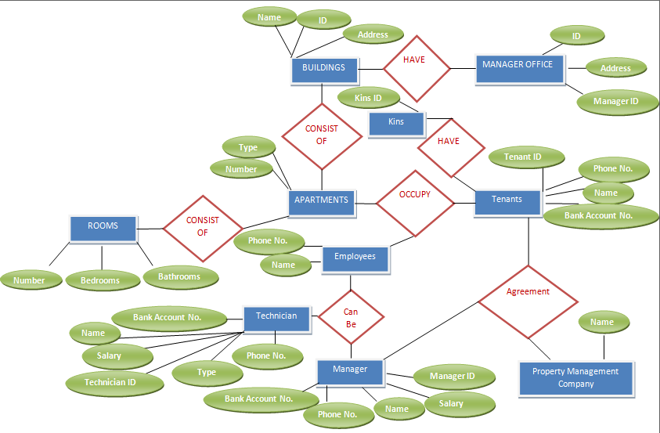

## Operating Environment

The environment in which the software is going to be operated includes hardware platform, operating system and its further versions. Other software components or so called applications in which it will work effectively and efficiently. The environment is a property management system in which data is added, deleted, searched etc. The hardware required for it must be at least 8GB (Giga Byte) RAM and about more than 4 TB (terra byte) storage. The operating system will be most probably Microsoft Windows 8.

# External Interface Requirements

## Hardware Interfaces

The devices that are able to support this property management system must be advanced according to the technology being used.

## Software Interfaces

The operating system on which the property management system is working is Microsoft Windows 8.

# Other Non-functional Requirements

## Performance Requirements

System’s performance i.e. working of the system is very good. There is no lagging in the system which makes it efficient. There are no such difficulties in using the system i.e. it is easy to use. The accuracy of the performance of the system is full 100% which makes it very efficient.

## Security Requirements

The personal information of the tenants, employees etc. are safe and secured in this management system. The data is stored in it and the safety precautions are taken place by installing the firewall. The authentication is essential to use the system. Without authenticating the admin cannot perform administrator functions and this authentication is done by the logging in.

# 2.2

## Designed Database

The database is designed with the help of MS Access. The database designed for the property management company in which its records are stored. E.g. the records about the buildings, apartments and tenants etc. that are being managed by the property management company are stored in the database that is designed in the MS Access. The relationships and the tables for the database are mentioned. The screenshots are given below.

## Relationships

## Tables

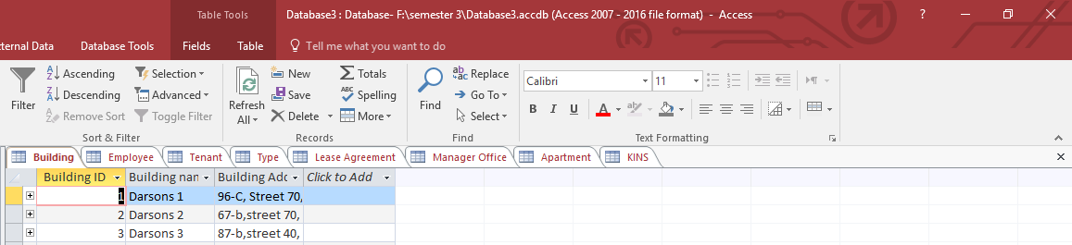

### Building Table

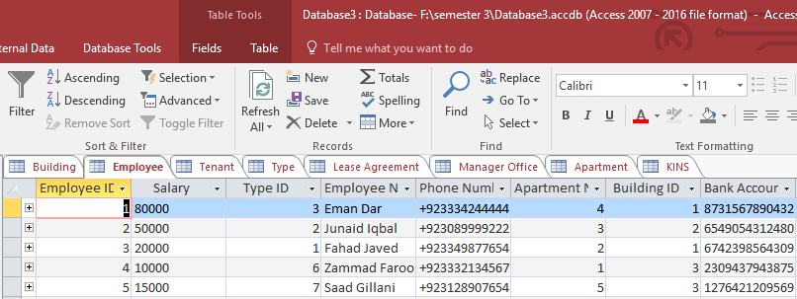

### Employee Table

### Tenant Table

### Type Table

### 

### Lease Agreement

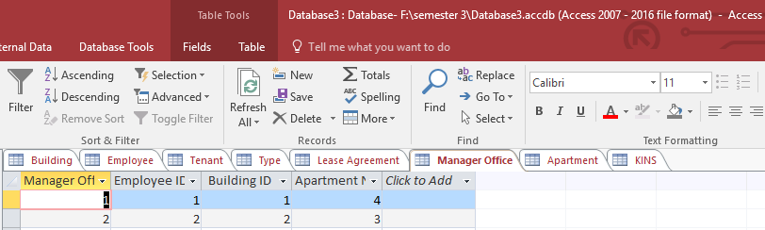

Manager Office

**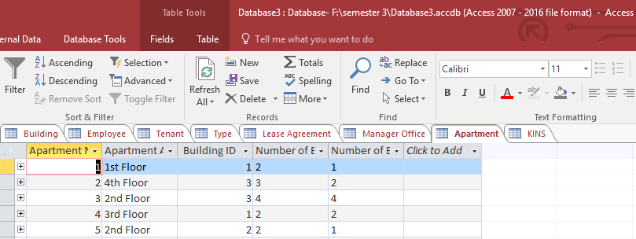**Apartment Table

**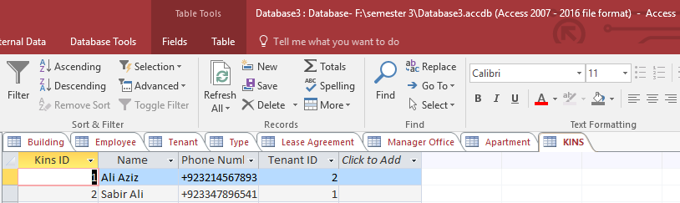**

Kins Table

# **2.3**

## **Types of Forms**

The forms used in designing a database are auto-generated. The auto-generated forms mean that the forms will be generated automatically of the specific table of which the forms are generated. Forms can be auto-generated, form-wizards and etc. But in designing this database the forms used are auto-generated.

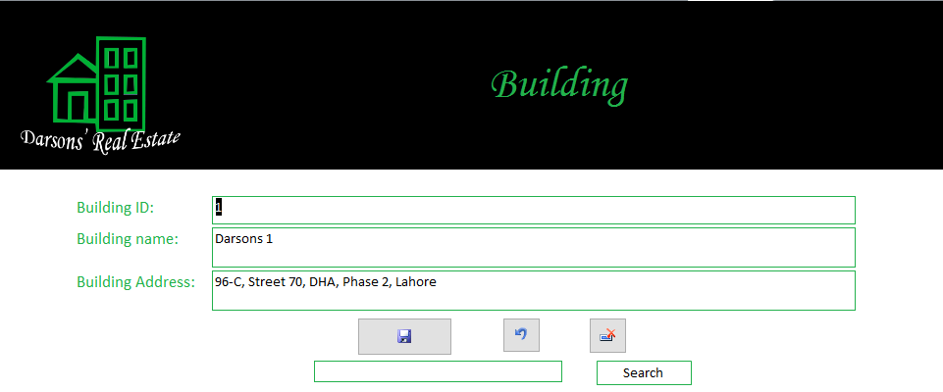



**ADD**



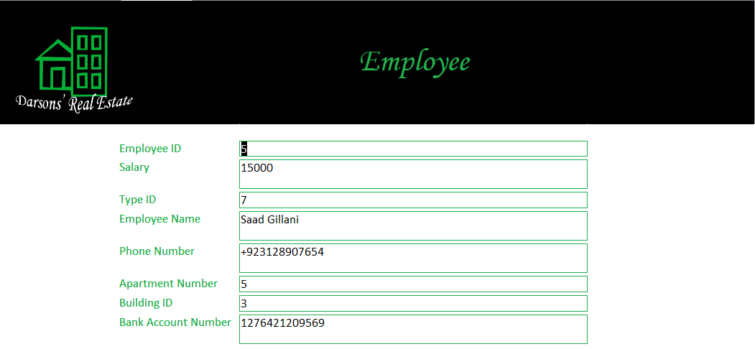

**DELETE**

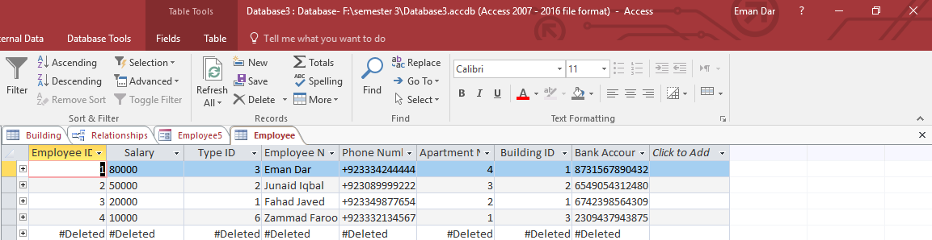

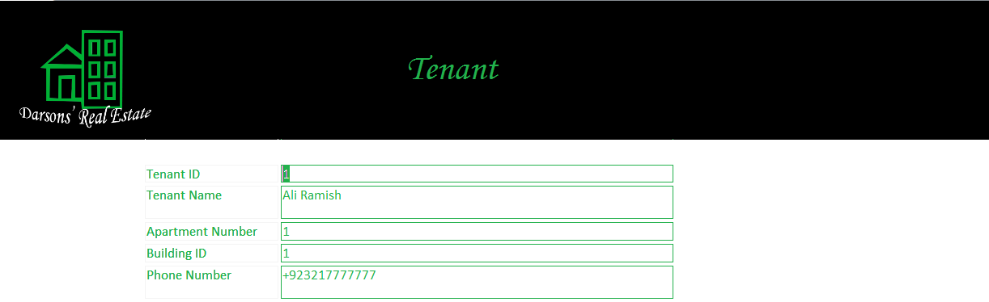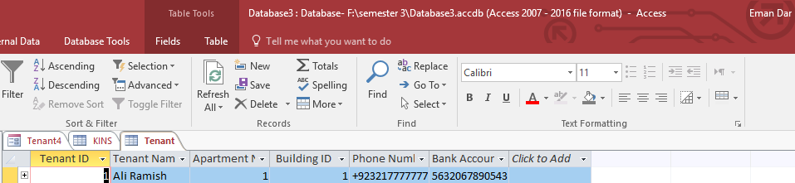

**Search**

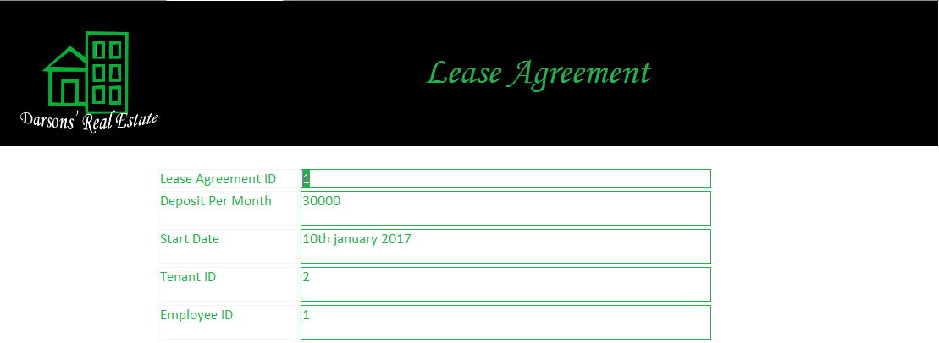

**Update**

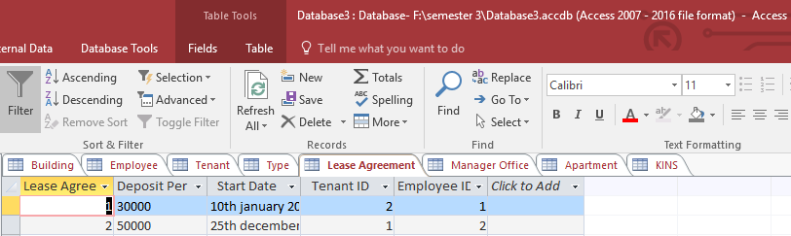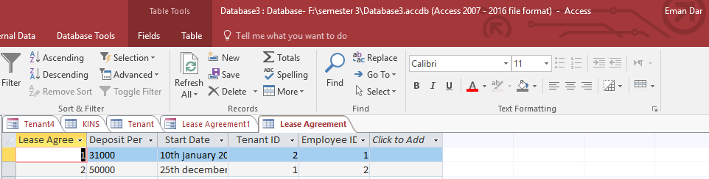

Updated

**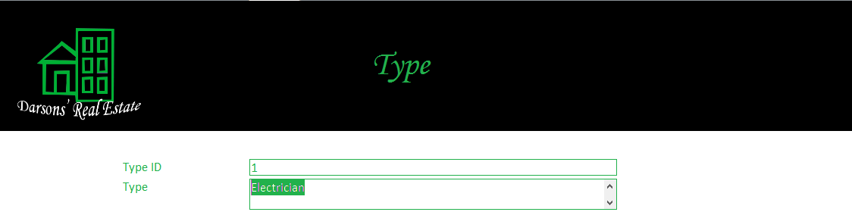**

**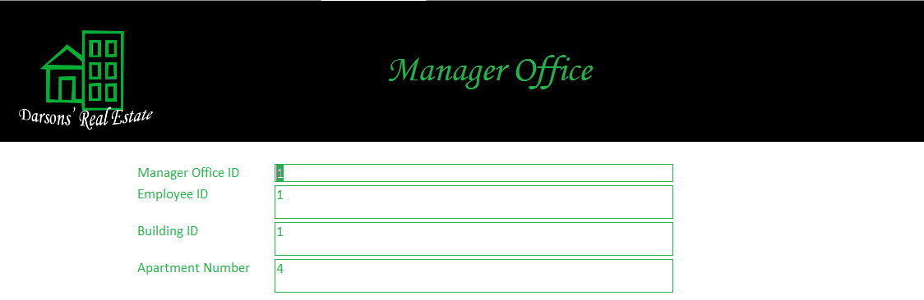**

**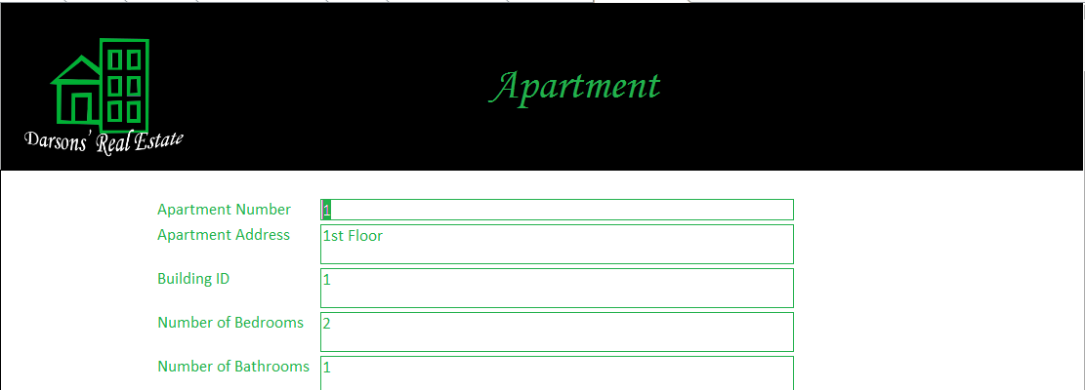**

**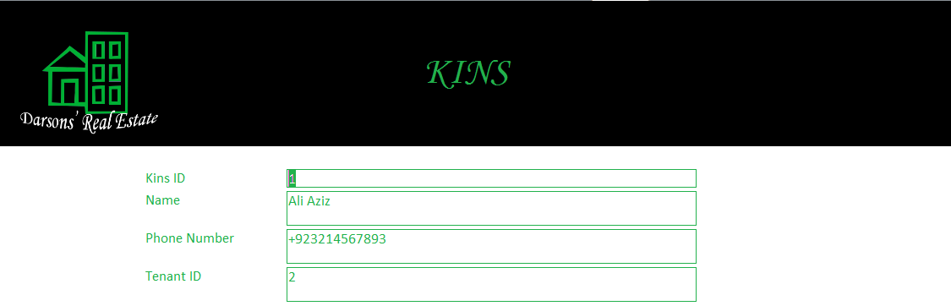**



# 3.1

## Query Tool

The query tool used for database is MS Access 2016. There are following benefits of MS Access 2016 due to which this query tool is used.

### Benefits

MS Access gives fully functional RDBMS (Relational Database Management System) in minutes to the data manager. The Access provides different wizards with which the data can be managed step by step. It is easy to integrate because it works with products known as Microsoft SQL Server in the front end as back-end tables and also with the products that are non-Microsoft products such as Oracle and Sybase. It is very .NET friendly as with the help of it linking to the database becomes easy and because of its GUI (graphical user interface) the functionality gets easy. It has a convenient storage capacity that is of 2GB. With the plus point that the data can easily be imported with the help of MS Access it gets more efficient. (learnitanytime, 2013)

In Access different types of approaches are given for designing and developing a database that are GUI tools i.e. the tools that are given on the graphical interface of MS Access, coding, applying query etc.

**Data Definition Language**

**“**The language with the help of which tables, indexes and users are modified, created and removed is known as Data Definition Language (DDL).**”** (techtarget, 2015)

**Data Manipulation Language**

**“**The language with the help of which data in database is retrieved, stored, modified and delete, inserted and updated is known as Data Manipulation Language (DML).**”** (stackoverflow, 2010)

In designing and developing this database the tools that are used are GUI tools. In this DDL (Data Definition Language) is not used in designing and developing this database instead of it DML (Data Manipulation Language) and GUI tools are used. DML is used for the queries.

# 3.2

## Query Implementation

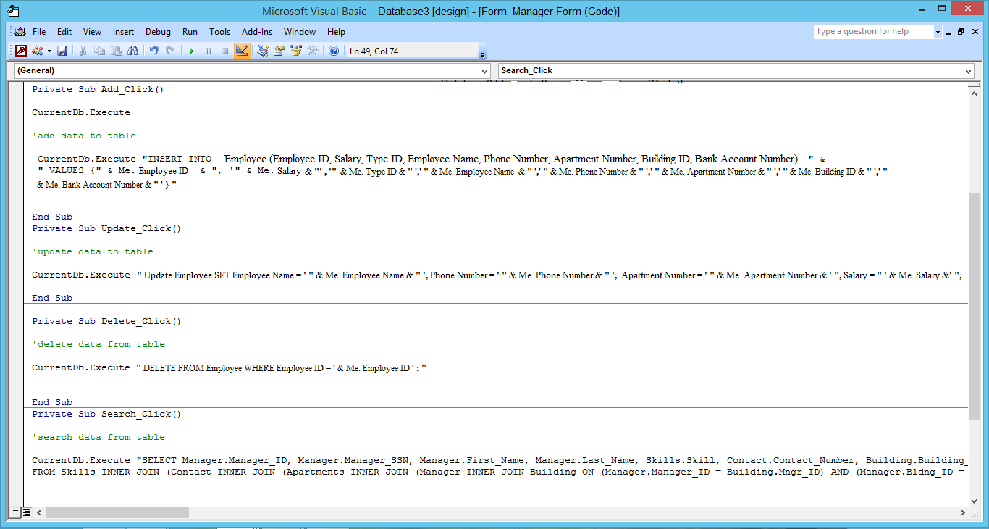First of all the tables are developed in which all the columns with information are mentioned. The forms are developed with the help of which the columns in the respective tables are inserted with the information according to that specific table. The queries are applied in the forms to insert delete or update the respective data. E.g. In the **Employee Table** the columns are Employee ID, Salary, Type ID, Employee Name, Phone Number, Apartment Number, Building ID and Bank Account Number. All these columns are filled with the data by applying a query on the add button that will be of **INSERT** and if the data needs to be updated the **UPDATE** query is applied on the update button which will help the user to change/update the information that is inserted in the columns of the table. If the information is no more essential/necessary than after clicking on the delete button the specific information gets deleted behind this button the **DELETE** query is applied which will help the user to delete the specific data. For searching something search bar is given where after typing the information the search button is clicked to search the data according to the specific information entered by the user behind which the **SELECT** query is applied which help the user to search the data.

# 3.3

## Critical Evaluation

### Retrieving Meaningful Data

The relation between apartment and building is established in the designing and developing the database by calling **Building ID** as foreign key in apartment’s table from the building table. The meaningful data is retrieved with the help of this relationship of building table with apartment table. The number of bedrooms and the apartments are retrieved from this query from respective buildings. The **SELECT** query is applied which helps to retrieve all the respective data. The retrieving of the data is shown below for more understanding.

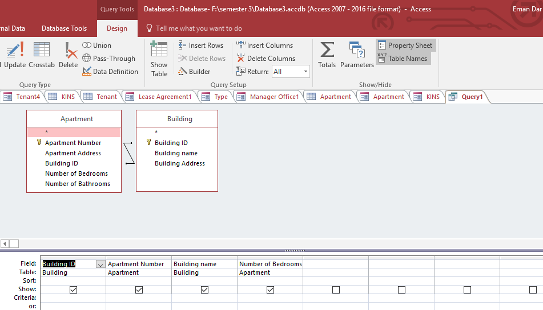

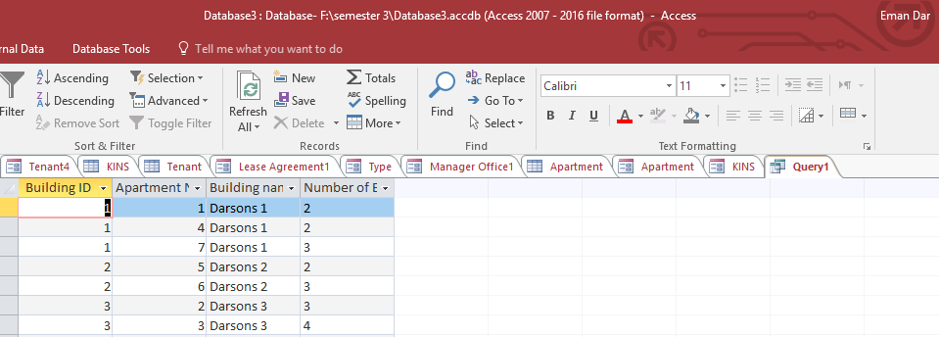

### SELECT Query

The SELECT query is used to select information and retrieve that is mentioned in the query. E.g. if the building table is selected and from building table it’s columns are selected that are Building name and Building ID and explaining the relationship between Building table and Apartment table so, from the apartment table it’s columns are selected that are Apartment number, Number of Bedrooms and then with the help of SELECT query all the data that is mentioned in the query are retrieved and are then shown in the form of table as shown below for more understanding.

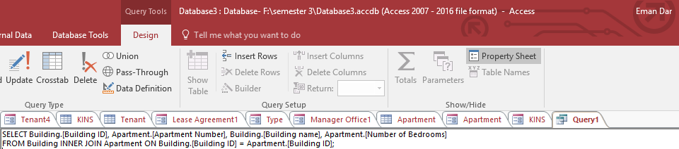



# 4.1

## Critical Review

The management system is working properly throughout as required. The requirements that are the property management company own different building and each building has different amount of apartments. So, it is necessary to mention the tables of building and apartment respectively. As per the requirements there should be the number of bedrooms and bathrooms given in the table of apartments so the company can have the track of it. Different kind of people also needs to be handled. The people are tenants and the employees of the company. So, to fulfil this requirement the table of tenant and employee in which their different information are mentioned. As every person must have a name, contact number so the company can have a track of it. So these columns are also mentioned in the report. The bank account number is mentioned in the table of tenant and the employee because the company needs to have a record of it i.e. if the person is the tenant then to deduct the rent the bank account number is necessary and if the person is employee then to keep the track of his monthly salary the bank account number is essential. For tenants there must be information of the kins for the contact purpose that if the tenant is not there at any moment then the kin mentioned can be contacted, the kin must have a name and the contact number for the contact. The employee can be of two types i.e. technician or manager. So, to fulfil this purpose the table of type is mentioned in which against the ID the name of the type is mentioned which can be manager, carpenter or both and same like this all the types are mentioned according to the requirement. The lease agreement table is also mentioned because with the help of lease agreement there could be a contract between the tenant and the company.

## Testing

### Input Testing

|  |  |  |  |
| --- | --- | --- | --- |
| Text-field | Data Type | Input | Result |
| Tenant (Bank Account Number) | Number  -----  ----- | Abcrtujloi  +92sddsdde  9234789091231 | Pass Fail  Pass Fail  Pass Fail |
| Building ID | Number  -----  ----- | iuyeedc  +92sytgv  12 | Pass Fail  Pass Fail  Pass Fail |

|  |  |  |  |
| --- | --- | --- | --- |
| Text-field | Data Type | Input | Result |
| Type | Short Text  -----  ----- | Null  +92sddsdde  923478909 | Pass Fail  Pass Fail  Pass Fail |
| Building name | Short Text  -----  ----- | iuyeedc  Null  12aerfb | Pass Fail  Pass Fail  Pass Fail |

# 4.2

## Support

### For Implementation

|  |  |  |  |  |
| --- | --- | --- | --- | --- |
| Table Name | Attribute | Primary Key | Form | Relationships |
| Building | Building ID  Building name  Building Address | Building ID | Building | Apartment / Tenant / Employee / Manager Office |
| Employee | Employee ID  Salary  Type ID  Employee Name  Phone Number  Apartment Number  Building ID  Bank Account Number | Employee ID | Employee | Apartment / Building / Manager Office / Lease Agreement |
| Tenant | Tenant ID  Tenant Name  Apartment Number  Building ID  Phone Number  Bank Account Number | Tenant ID | Tenant | Apartment / Lease Agreement / Building / Kins |
| Type | Type ID  Type | Type ID | Type | Employee |
| Lease Agreement | Lease Agreement ID  Deposit Per Month  Start Date  Tenant ID  Employee ID | Lease Agreement ID | Lease Agreement | Tenant / Employee |
| Manager Office | Manager Office ID  Employee ID  Building ID  Apartment Number | Manager Office ID | Manager Office | Employee / Apartment / Building |
| Apartment | Apartment Number  Apartment Address  Building ID  Number of Bedrooms  Number of Bathrooms | Apartment Number | Apartment | Building / Employee / Tenant / Manager Office |
| Kins | Kins ID  Name  Phone Number  Tenant ID | Kins ID | Kins | Tenant |

### For Testing

The testing performed for the developed relational database system is input testing. With the help of input testing the data entering in text fields is tested that whether the checks are working or not. E.g. if there is a data entered in the text field is against the data type then it will give the error or it will not accept the entry like, if the data type is number and the data is entered in the form special characters or the alphabets then it will give an error or it will not accept the entry. So, to enter the value in it the value must be in the form of numbers.

# 4.3

## User Documentation

* To access the property management system the user needs to login first and after the login user can access all the features.
* The forms are developed for the property management system i.e. for its database.
* The tables are designed and developed for it according to which the forms are made in which the data is inserted, deleted, updated and searched.
* The Add button is given in the forms designed and developed according to the specific tables. With the help of this the data that needs to be added is inserted as a record in the database as shown in the tables.
* The Update button is given in the forms that are designed and developed for the respective tables. With the help of this button the data that is already there in the tables can be updated if needed and the changed / updated record is shown in the table.
* The Delete button is available in the forms that are designed and developed with respect to the tables that are given in the designed and developed database. With the help of this button the data that is no more important or essential to be there in the record can be deleted that deleted data will vanished from the tables made.
* The Search bar is given in designed and developed forms against the respective tables in the database. With the help of this search bar the data can be searched according to the data is entered in the search bar and by clicking on the search button that is given beside the search bar the data can be searched.
* Different tables are given according to the requirements that are: Building, Apartment, Tenant, Employee, Manager Office, Lease Agreement, Type, Kins. And the forms against the respective tables are designed developed for performing the functions.

# 4.4

## Validation and Verification

### Verification

The data entered if is against the data type e.g. the data type is number and the data entered is in the form of alphabets or special characters the error message will be displayed that data entered is of wrong type is **verification**. These checks are hidden from the user i.e. are done at the back end of the interface.

### Validation

To check that whether the data entered is already there in the database or not and if it is already there then the error message will be displayed is **validation**. E.g. if the user wants to sign up and enters the username that is similar to someone then it will given error that is already taken i.e. Eman is entered and if it is taken then message of already taken will be displayed and will give suggestion like, Eman1 etc. So, to save the user from this the ID is assigned to it which will differ from other usernames.

### Validation and Verification of System

The data is verified while developing and designing the database that whether the verification is working or not like the data type behind the error is given or not. The user enters the data that is against the data type behind the text fields given in the forms of the tables.

The data is validated that whether the requirements gathered are accurate and authentic or not. The designed and developed system is according to all the requirements that are gathered after different meetings with the company. The designed and developed database is perfectly working or not. Is there any problems in it are properly validated.

# 4.5

## Control Mechanism

The control mechanism for any developed designed is essential so for this designed and developed database the control mechanism is done by giving the login option that after logging in the administrator can access the functions of the property management system designed and developed. When the property management system is accessed the login screen is displayed on which the login option is given by entering the username and password the system’s functions can be accessed. This procedure is shown below:

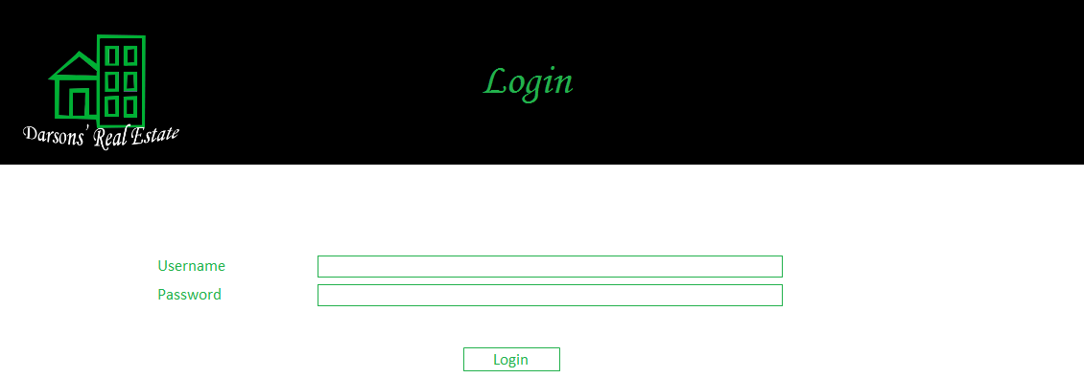

# Bibliography

learnitanytime. (2013, November 18). *Know The Advantages And Disadvantages Of Microsoft Access.* Retrieved from learnitanytime: http://learnitanytime.com/4031/know-the-advantages-and-disadvantages-of-microsoft-access-2/

stackoverflow. (2010, April 5). *what is ddl and dml.* Retrieved from stackoverflow: stackoverflow.com/questions/2578194/what-is-ddl-and-dml

techtarget. (2015). *Data Definition Language DDL.* Retrieved from techtarget: whatis.techtarget.com/definition/Data-Definition-Language-DDL